**Let it Glow: Bioluminescence in the Sea**

Joie Cannon, Jessica Goodheart, Andrew Swafford, Emily Lau

**Materials**

[Pestles](https://www.amazon.com/1-5ml-Pestles-Assorted-DNase-RNase/dp/B078SYRCMV/ref=sr_1_26?ie=UTF8&qid=1548185749&sr=8-26&keywords=plastic+pestles)

[1.5 mL test tubes](https://www.amazon.com/1-5ml-Container-Sample-Plastic-Choice/dp/B01EFF9S9E)

[Dried C. hilgendorfii](https://www.carolina.com/cellular-physiology-enzymes/sea-firefly-cypridina-hilgendorfii/FAM_203430.pr) - Carolina Biological Supply Company

Water

[Pipettes](https://www.amazon.com/Roylco-R5449-Paint-Pipettes/dp/B000F8TCQA/ref=sr_1_5?s=toys-and-games&ie=UTF8&qid=1548186116&sr=1-5&keywords=pipettes)

[LED Lights](https://www.amazon.com/Etekcity-Finger-Supplies-Holiday-Assorted/dp/B00D62VF1W)

Signal cards

Pens/Pencils

*Bioluminescence and bioluminescence communication activities need to be done in a semi-dark room, so covering the windows with dark cloth may help.

**Introduction**

Bioluminescence is a widespread phenomenon that can be seen in a vast array of organisms, especially those inhabiting marine environments ([National Geographic Bioluminescent Creatures Documentary](https://www.youtube.com/watch?v=-h79qFs-dEY)).

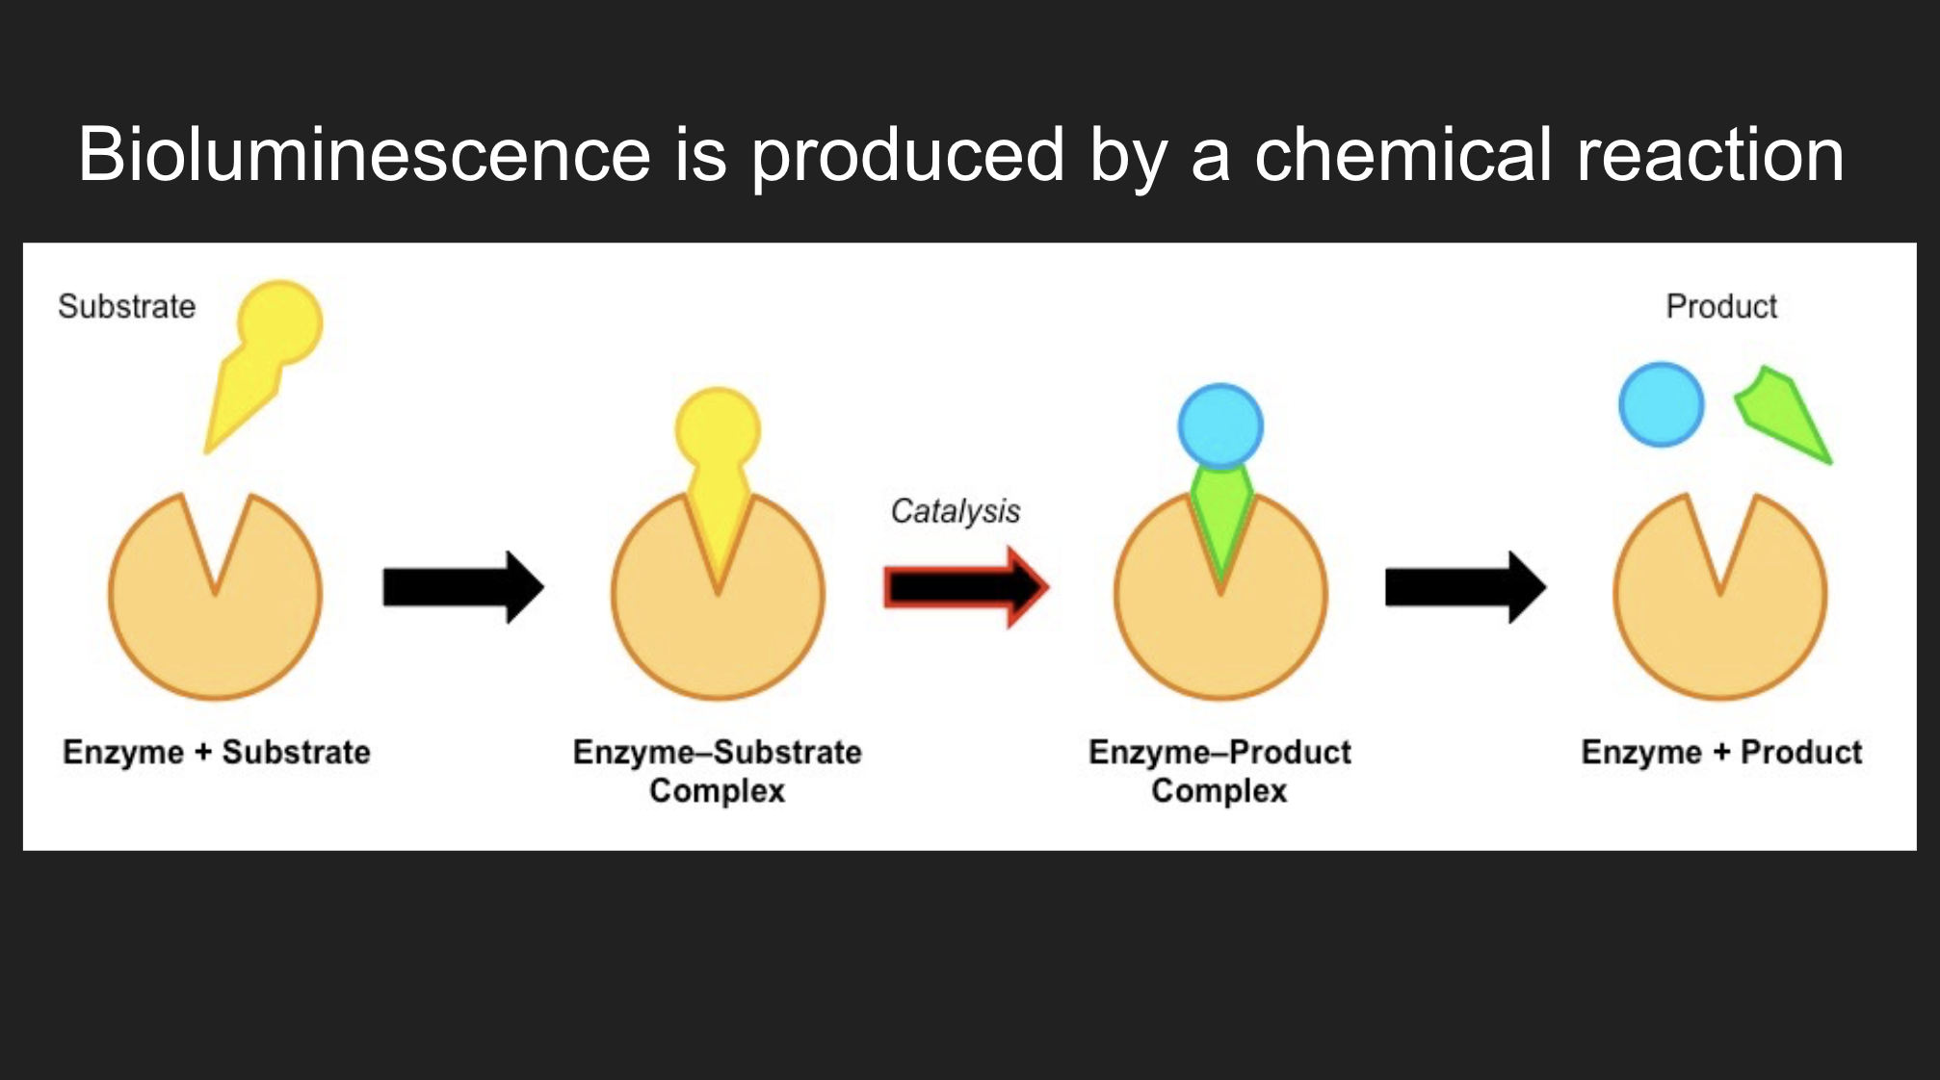

Bioluminescence is light produced by a chemical reaction when a substrate binds to an enzyme.

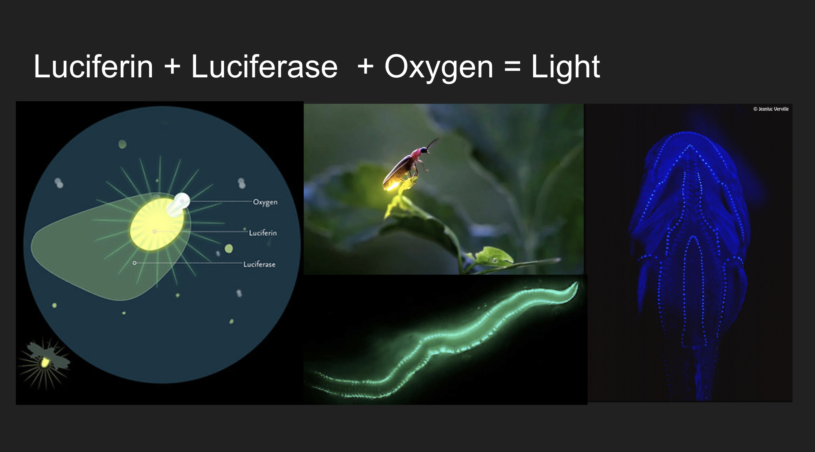

When the substrate (luciferin) is in the presence of oxygen, the enzyme (luciferase) catalyzes the oxidation reaction and produces light. These are examples of organisms that use luciferin and luciferase to bioluminescence: fireflies, polychaete marine worms, midshipman fish. Midshipman fish produce their own luciferase, but eat small crustaceans to obtain their luciferin, which they then use for their own bioluminescent reactions! There are about 700 light organs, or photophores, all around the body of the midshipman fish.

**Bioluminescence activity**

Preparation prior to activity: Place 10 - 15 animals in a 1.5 mL test tube. Fill some jars/ larger test tubes with water.

Bioluminescent ostracods are small crustaceans that live in the ocean. These ostracods were collected and dried from Japan (C. hilgendorfii).

Activity: Pass around water, test tubes with the animals, and pipettes. Pipette ~ 0.75 mL of water into the test tube containing the animals. Turn off the lights, then use the pestle to crush the animals. You should observe blue bioluminescence!

The bioluminescence will diminish after some time. When you crush the animals in water, the chemical reaction is occurring - the luciferase is oxidizing the luciferin. When all the luciferin is oxidized, there is no more substrate left to react and light is no longer produced. However, the luciferase enzyme is still present in the test tube. If you add pure luciferin substrate into the test tube, light will be produced.

**How do organisms use bioluminescence?**

Organisms use bioluminescence for various functions such as: defense, to lure prey, to camoflauge, attract mates. What do these functions have in common? They are all ways to communicate!

**Ostracods**

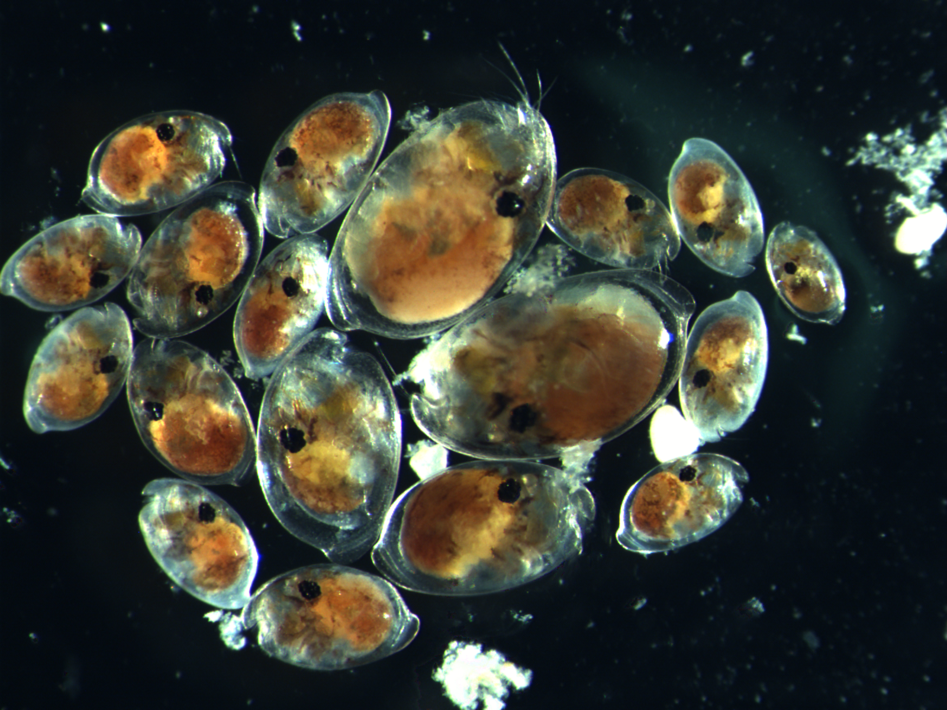

The animals that were crushed up in the tubes are ostracods - they are also called seed shrimp.

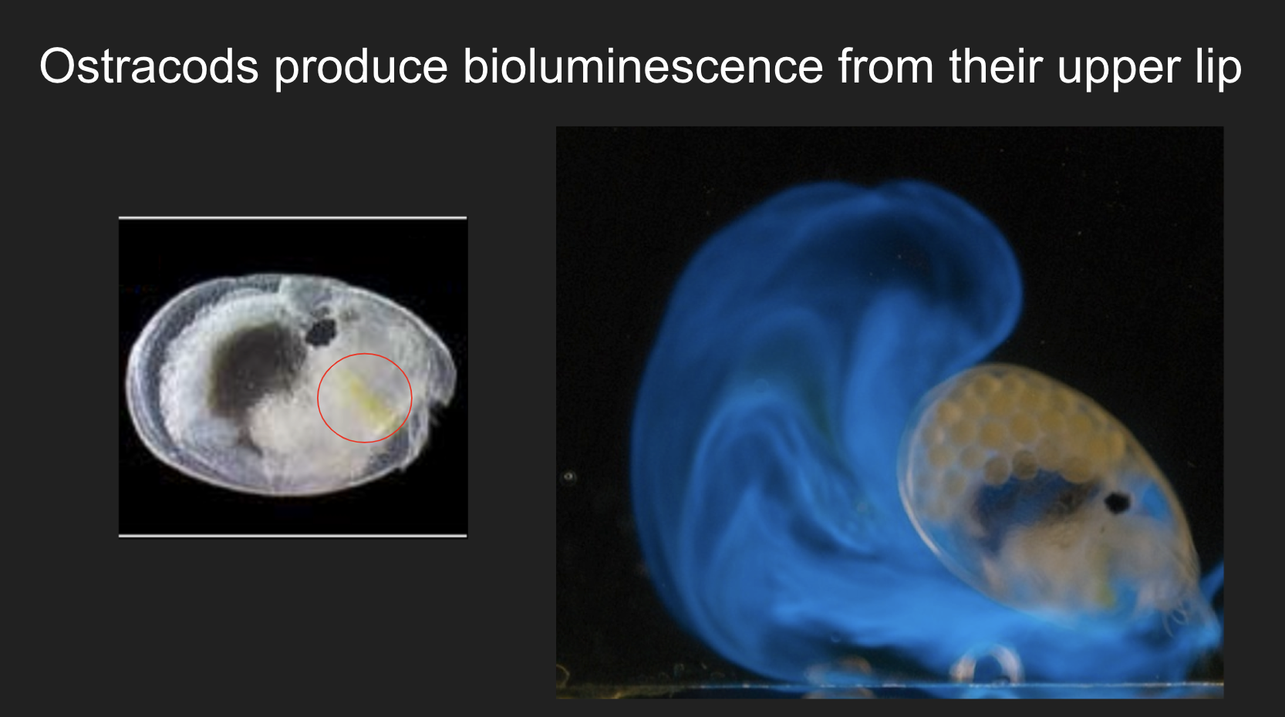

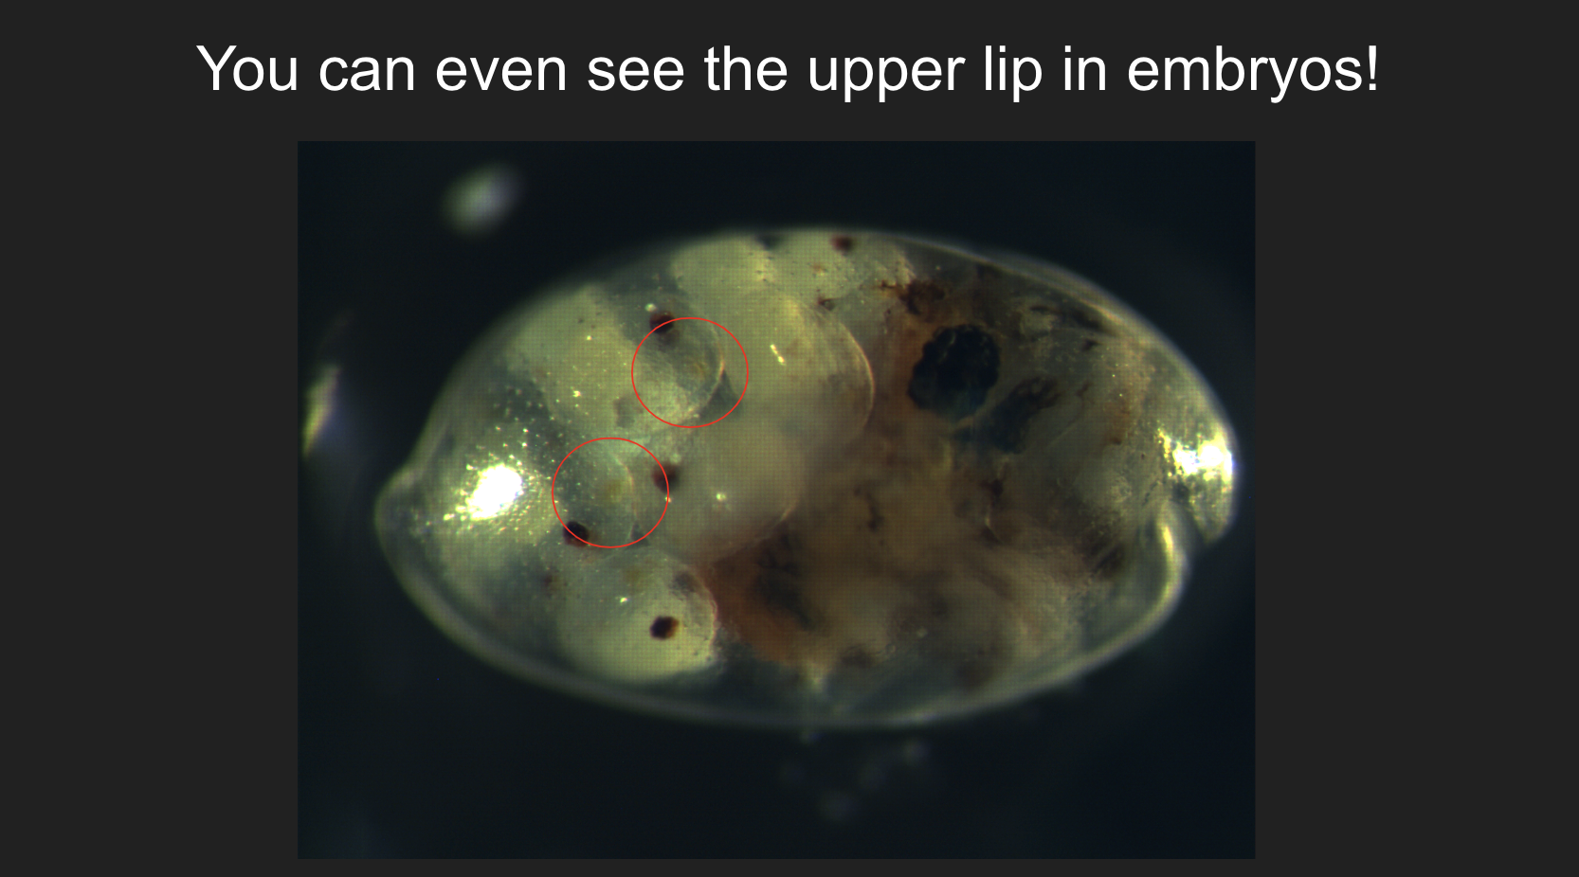

Ostracods produce bioluminescence from their upper lip.

In some species, ostracods use bioluminescence only to deter predation. In other species, ostracods use bioluminescence to signal to and attract mates. Bioluminescent signaling in ostracods can differ in pulse duration, directionality, and speed.

**Bioluminescence communication activity**

In this activity, students will use LED lights to flash a specific pattern in order to find their partner. Their partner will be flashing the same pattern. This is similar to how ostracods look for their species specific signal.

First run: Distribute the first set of signal cards, which are all the same pattern. Explain how to signal using the LED light and an example signal (ex: a signal that requires you to signal three times in a horizontal manner - flip the switch on and off three times from the left to the right).

In the first run, all students will be signaling the same pattern with the same color light (blue). Students will most likely fail to find their partner. This shows that if all ostracod species are signaling the same pattern, it would be difficult to find their mate. Ask students: if you wanted to find your partner more efficiently, what would you change? Possible answers are: the pattern, signal duration, light color.

Figure of different ostracod signals:

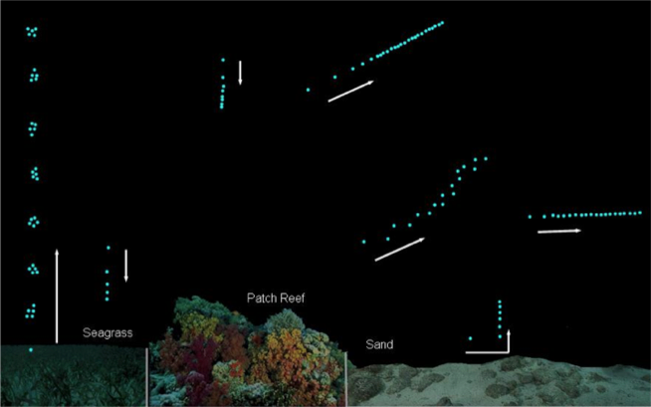

Ostracods diversified their signaling patterns - each species has their own unique pattern so they can find their partners more efficiently!

Second run: Distribute the second set of signal cards, which have different patterns.

In the second run, students will be signaling different patterns with the same color light (blue). Students should have an easier time finding their partner.

Last run: Distribute the set of signal cards which have options for students to select different LED colors and patterns.

During the last run, students will create their own pattern and have the option to use different LED colors! They will fill out a signal card with a partner and then hand the signal card to you. Distribute the signal cards randomly to the group and hand out colored LEDs to those who need them.

**Article:**

https://blogs.scientificamerican.com/artful-amoeba/the-starry-night-beneath-the-caribbean-sea/

**Luminous ostracod videos:**

<https://www.youtube.com/watch?v=8KRWhQeGrF8>

First few minutes: <https://www.youtube.com/watch?v=9HXXQBz6Vv0>